6/21/07 batch of VSV-ova: 2*10⁹ pfu/ml

ESTIMATED PRE-DILIUTION TITER: 2*10¹⁰ pfu/ml
ESTIMATED POST-DILIUTION TITER: 2*10⁹ pfu/ml
(Because of the high titer, the original stock of VSV-ova virus was diluted 1:10 with PBS, thus, aliquots at -80 are all at 2*10⁹ PFU/ml.) (With days in log scale; late time-point included)
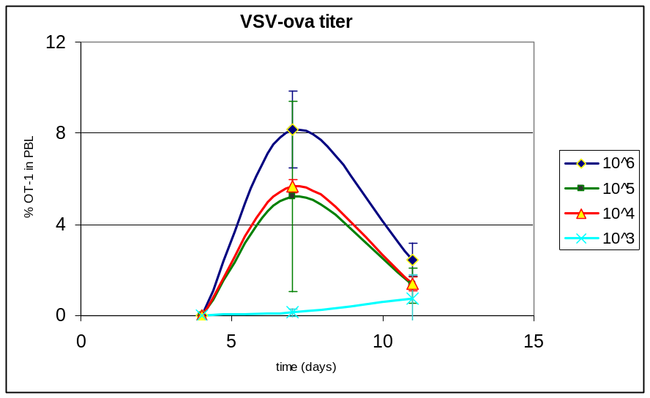
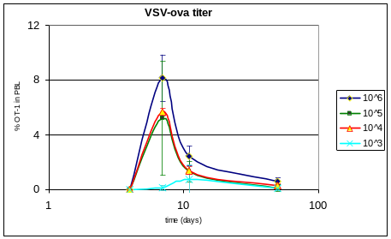
Injection of 10⁵ PFU of VSV-ova yields good CD8+ T cell response. Mice were adoptively transferred with 40,000 OT-1 T cells. Approximately 6 weeks later, mice were infected intravenously with the indicated amount of VSV-ova. PBL was collected at the times indicated, and donor OT-1 cells were identified by flow cytometric analysis of CD8 and CD45.1 expression.

Raw data for main titer of 6/21/07 VSV-ova batch:
number: | dilution | % lysed | # of wells lysed/total wells
1 | 1*10⁶ | 100% | 12/12
2 | 2*10⁶ | 100% | 12/12
3 | 4*10⁶ | 100% | 12/12
4 | 8*10⁶ | 100% | 12/12
5 | 1.6*10⁷ | 100% | 12/12
6 | 3.2*10⁷ | 100% | 12/12
7 | 6.4*10⁷ | 100% | 12/12
8 | 1.3*10⁸ | 100% | 12/12
9 | 2.5*10⁸ | 100% | 12/12
10 | 5.0*10⁸ | 100% | 12/12
11 | 1.0*10⁹ | 100% | 12/12
12 | 2.0*10⁹ | 75% | 9/12
13 | 4.0*10⁹ | 75% | 9/12
14 | 8.0*10⁹ | 50% | 6/12
15 | 1.6*10¹⁰ | 33% | 4/12
(See Kitty/Mark for details; briefy, BHK cells were plated in 96-well-flat bottom plates in 200ul;
undiluted virus was added at the indicated concentrations, and percentage of cells with lysed cells was counted 3-7 days later.)

Key for preparing 1*10⁵ per mouse VSV-ova injections with 2*10⁹/ml titer aliquots::
total volume | for 200ul per injection | for 250ul per injection | for 300ul per injection
10ml | 2.5ul | 2ul | 1.7ul
20ml | 5ul | 4ul | 3.3ul
30ml | 7.5ul | 6ul | 5ul
40ml | 10ul | 8ul | 6.7ul
50ml | 12.5ul | 10ul | 8.3ul

VSV-OVA aliquots are stored in the -80 freezer; each vial has a blue dot and orange ring on the lid;
each aliquot is intended for one use so please do not refreeze.

